**Advance Mathematics**

Lab 6

Yu-Hao Chiang 3443130

**Exercise 1 – Substitution and Wronskian**

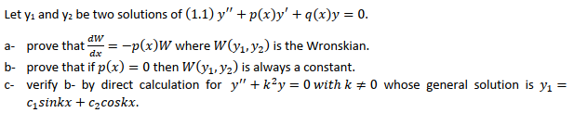

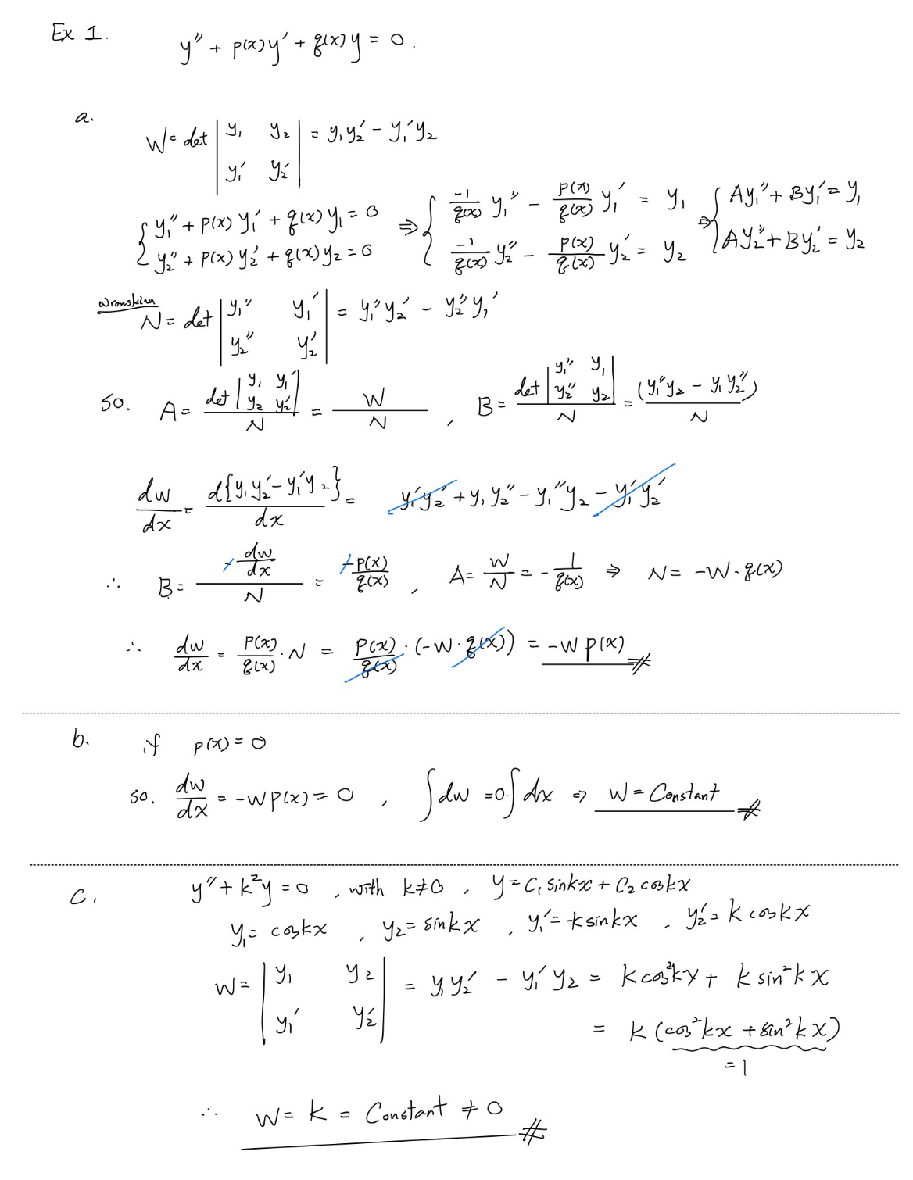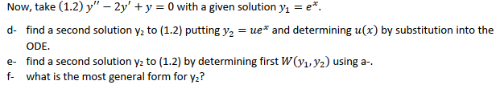

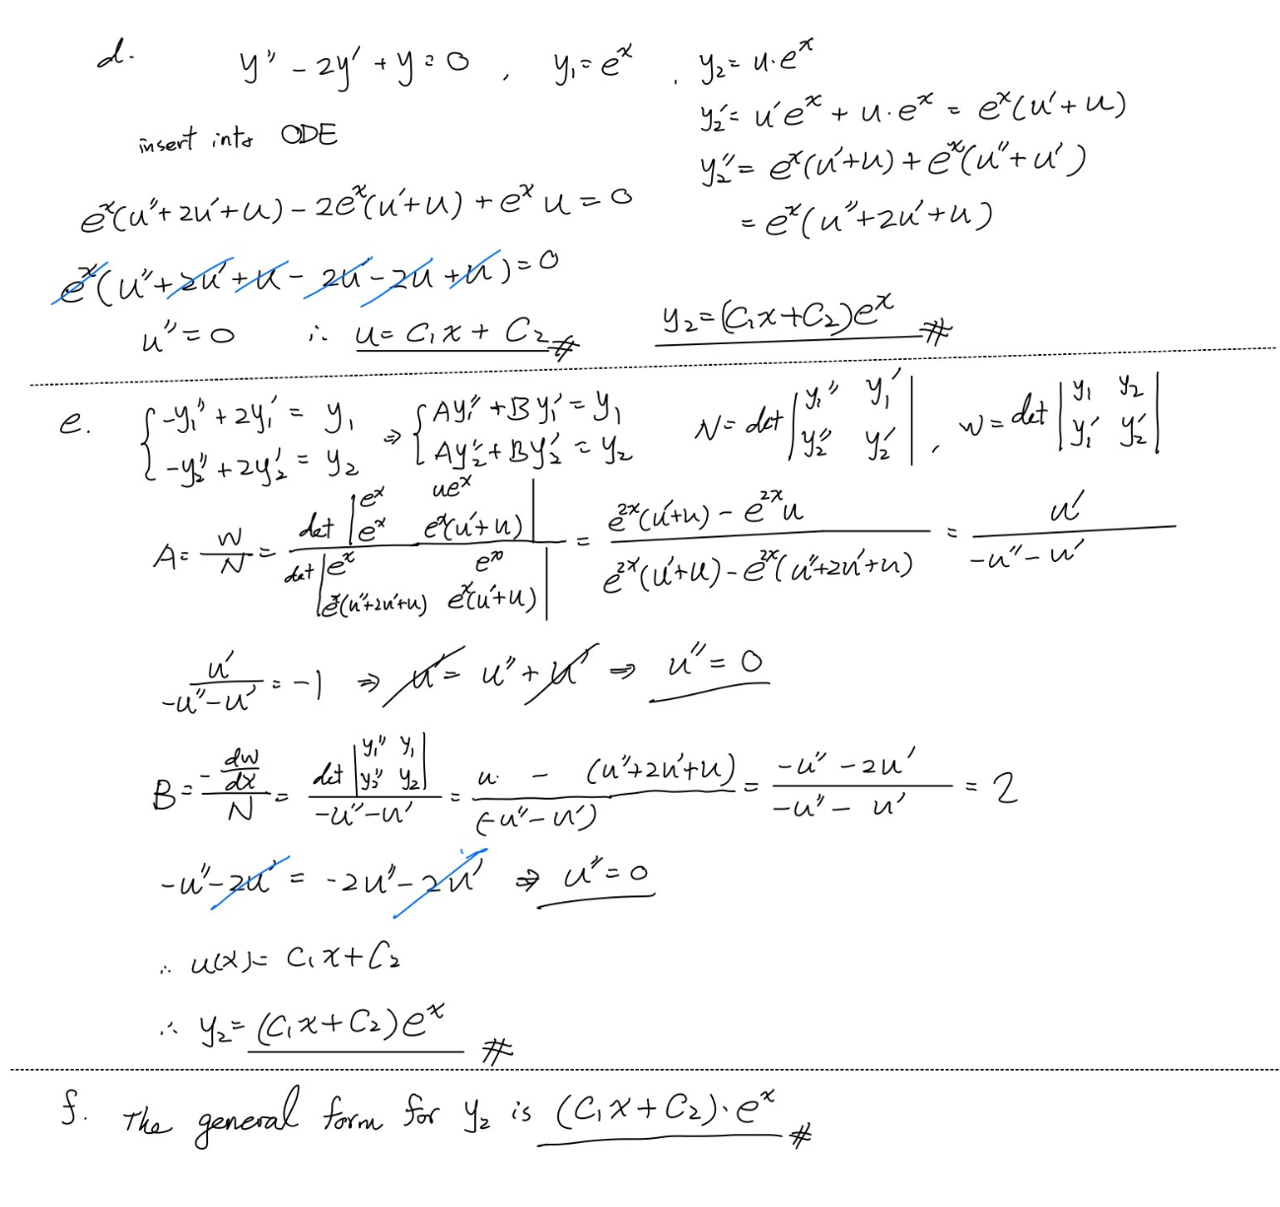

**Exercise 2 – Set up an ODE**

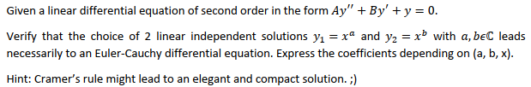

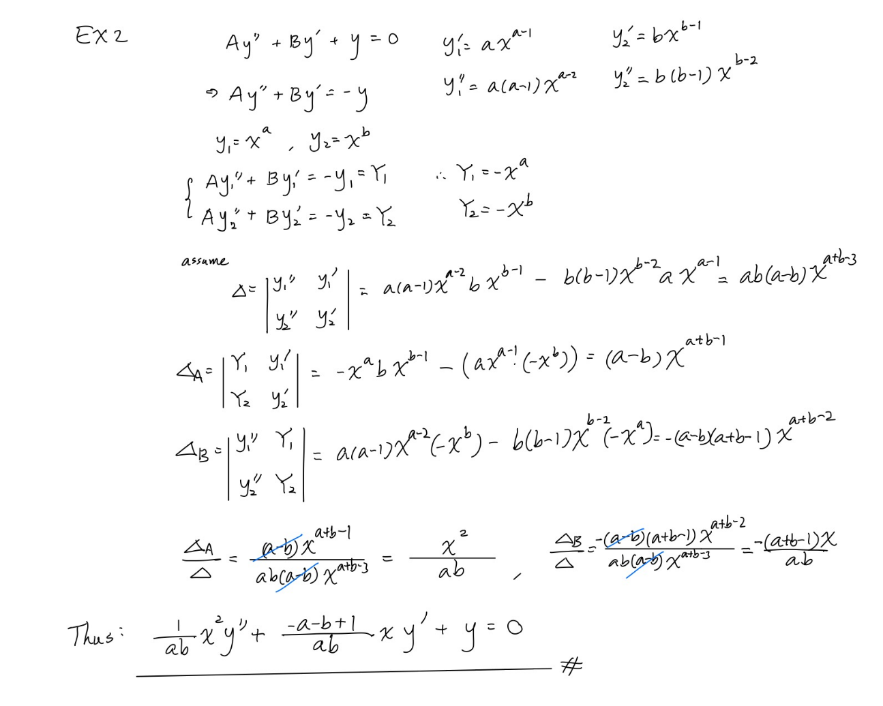

**Exercise 3 – Horner scheme on Matlab**

